**Exporting Printers**

1. Make a folder called **Data Migration Script** in your external drive or just copy the folder here and skip step two.
2. Ensure you have the 22backup_printers.bat and 22restore_printers.bat | RUN AS ADMIN!!!
3. Run 22backup_printers.bat
4. Type in your external drive’s drive letter.
5. Type in the user id of the person you want to save.
   1. Don’t know their ID? Check via C:\Users or ask them.
6. Wait for the script to finish.

**Example Recovery**

Type in drive letter and user id you are copying from. Script does the rest.

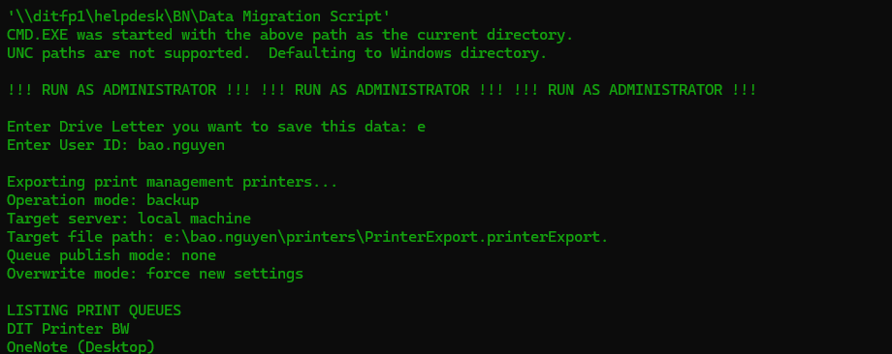

**Restoring Printers**

1. Delete any existing printers in print management and then Run 22restore_printers.bat
   1. If this is a brand-new PC there should be no printers installed.
2. Type in your external drive’s drive letter.
3. Type in the user id of the person you want to restore.
4. Wait for the script to finish.

***NOTE: Accounting Codes must be inputted by hand due to security!***

***Open Print Management as admin > Find Printer> Configuration Tab***

**Example Restore**

Type in drive letter and user id you are copying from. Script does the rest.

